Graphic Organizers
Number Bonds
Write the whole in the top circle and the two parts below it. Then write a number sentence for each bond.

Name | Date

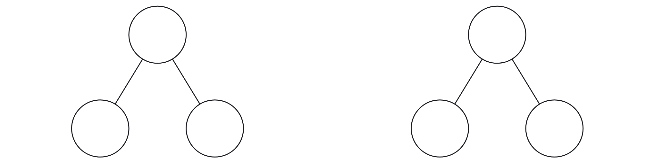

Number Sentence | Number Sentence

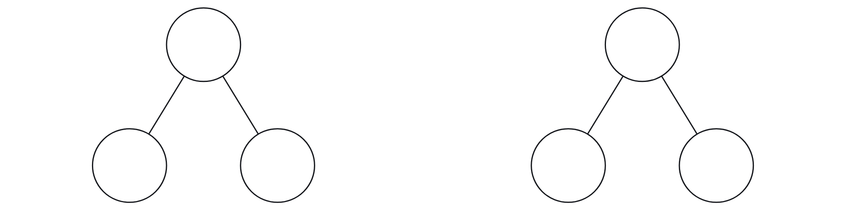

Number Sentence | Number Sentence

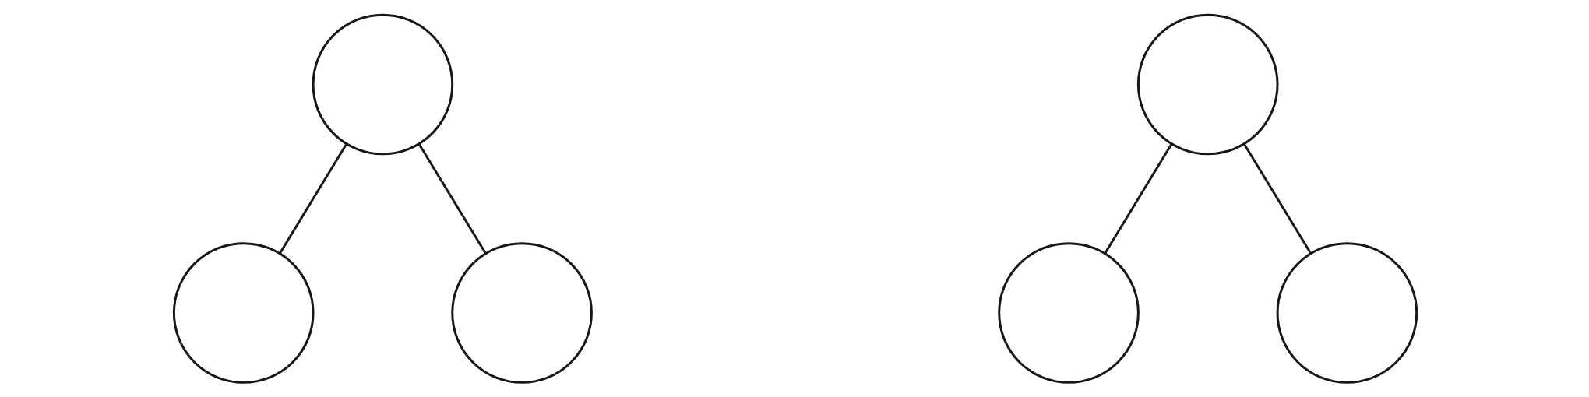

Number Sentence | Number Sentence

