Graphic Organizers
Double Bubble Map
Write a topic in each big circle. Likenesses go in the middle bubbles, differences on the outside.

Name | Date

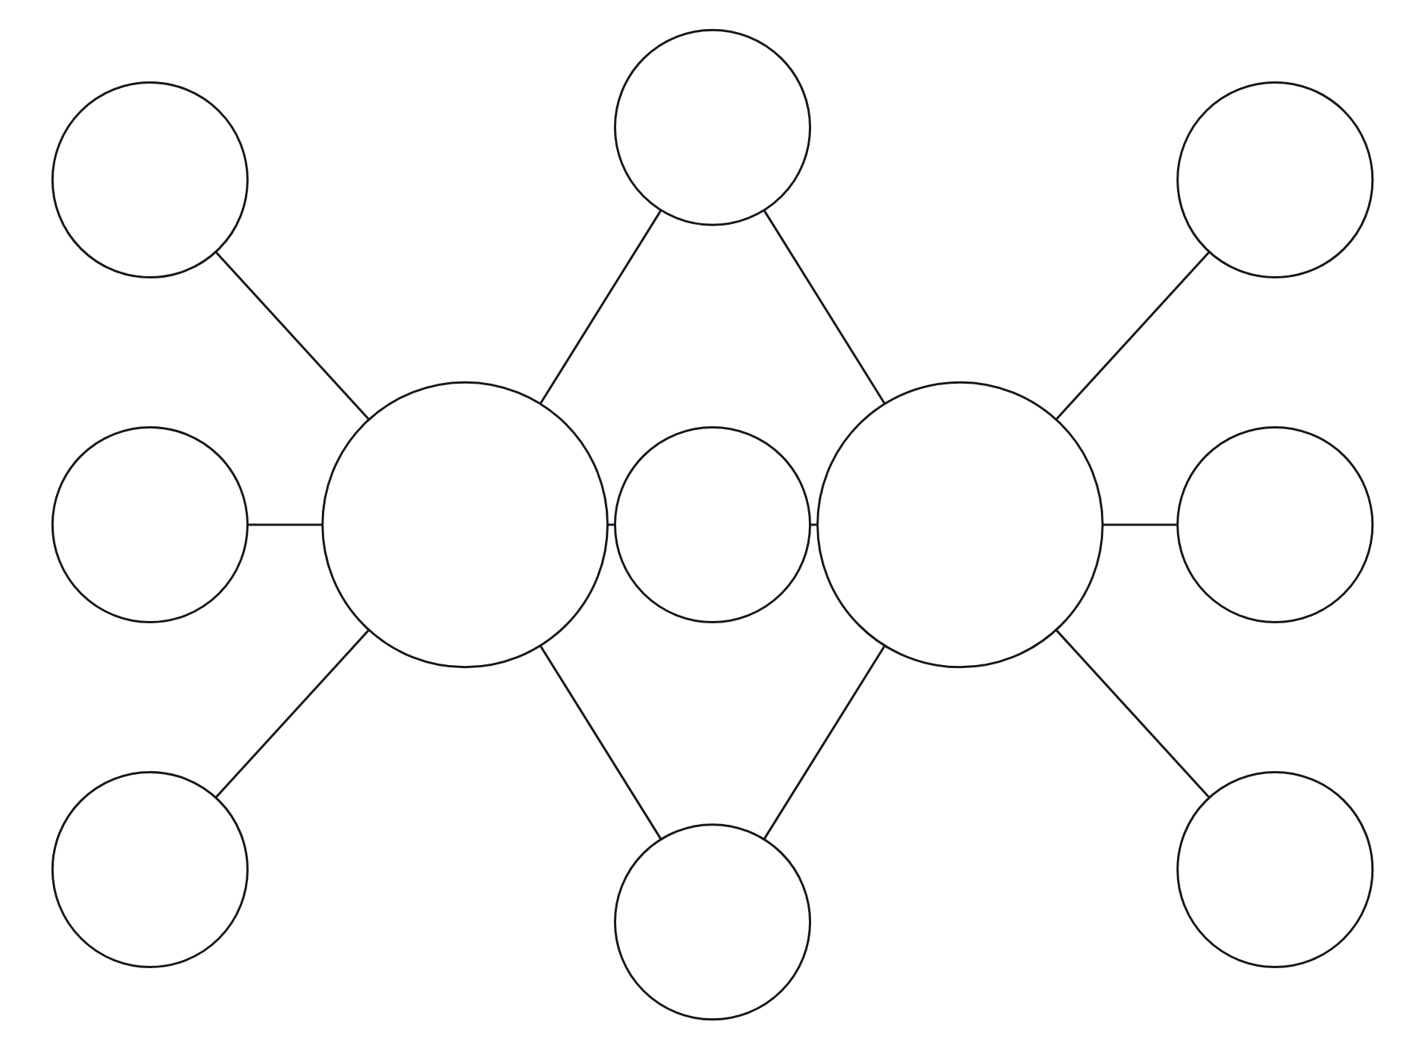

Compare Them in a Sentence

