Graphic Organizers
Character Traits
Write a trait in each bubble. Then choose three traits and prove each one with evidence from the text.

Name | Date | Title | Character

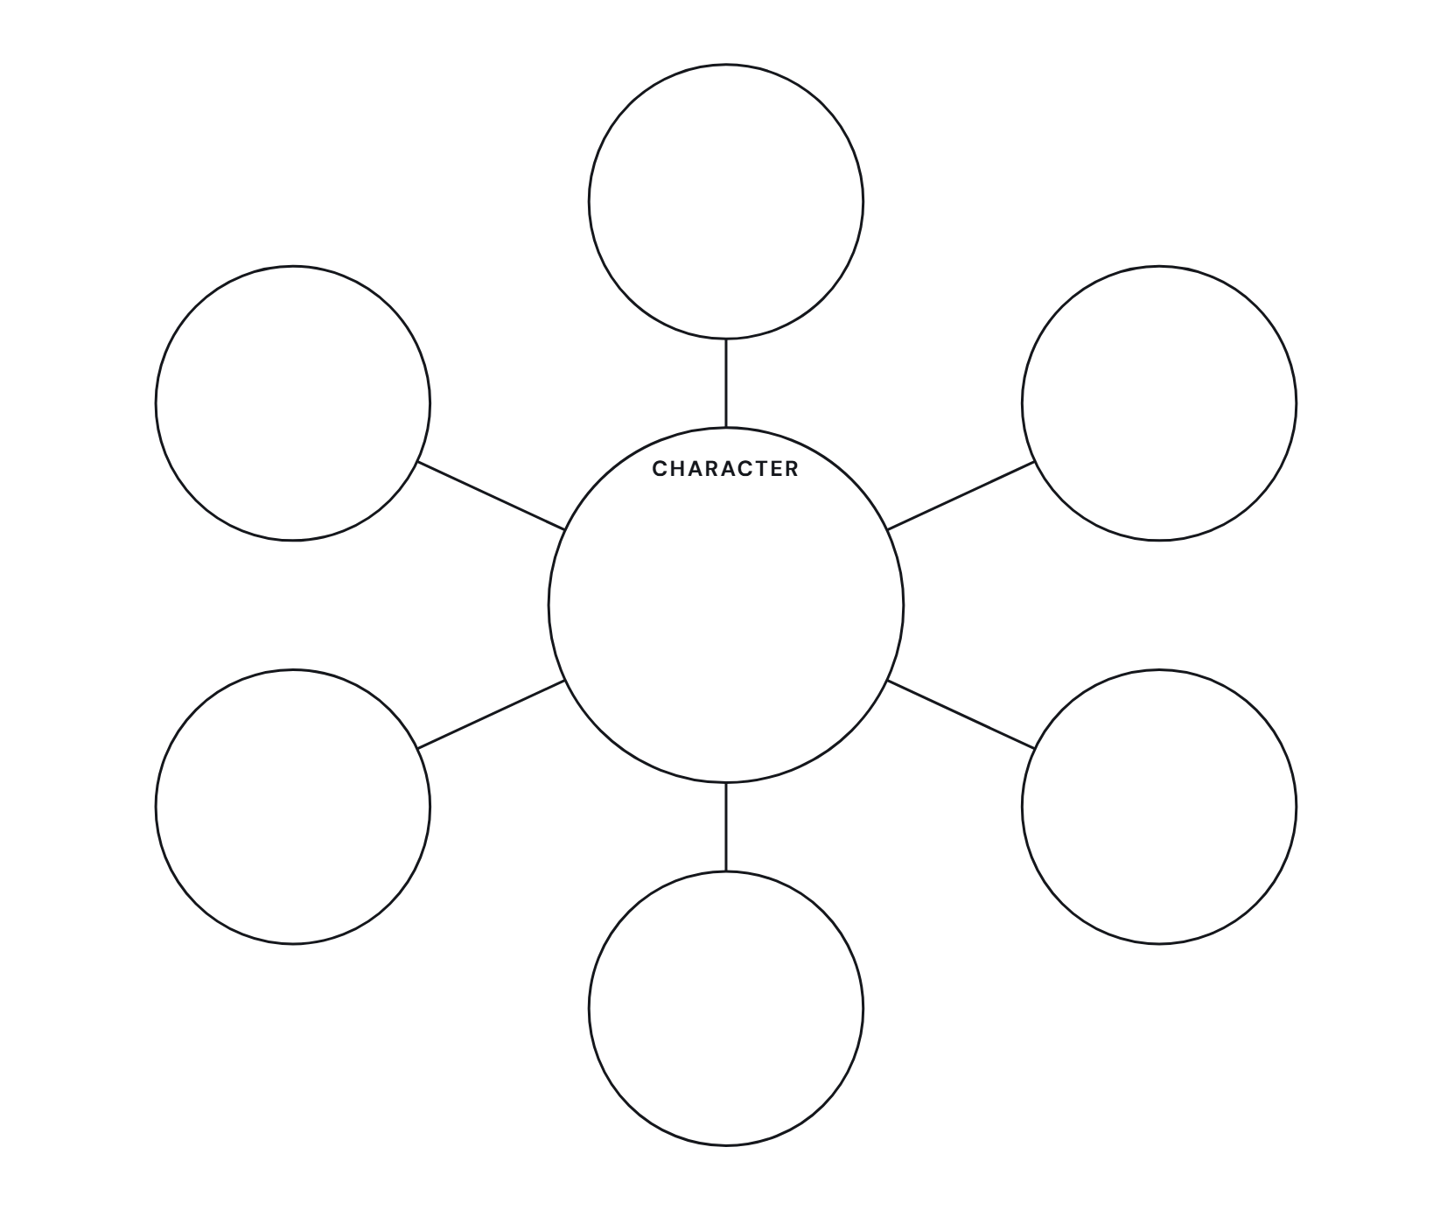

Trait | Evidence From the Text | Page or Chapter

