Classroom Organization
Substitute Teacher Binder
Inside: our schedule, procedures, seating chart, contacts, emergency plans and a page for your notes.

Teacher |  | Grade or Subject | Room | School
Welcome
Quick Facts | Details
School Hours
Parking
Sign In and Keys
Today's Lesson Plans
Attendance Is Due
Lunch and Recess
My Duties
Staff Restroom and Lounge
Copies and Supplies
Projector and Computer
Dismissal
If There Is Extra Time
Classroom Organization
Weekly Schedule
Our regular week, specials included. Check the plans folder for anything different today.

Time | Monday | Tuesday | Wednesday |  | Thursday | Friday
Students Who Leave the Room (Who, When, Where) |  |  |  | Duties and Meetings
Classroom Organization
Class Procedures
How we do things every day. The class knows these well, so ask a helper to show you.

Procedure | How We Do It
Morning Arrival
Attendance and Lunch Count
Getting Attention
Restroom and Water
Pencils and Supplies
Turning In Work
Early Finishers
Lining Up and Hallways
Technology
Behavior and Rewards
Dismissal
Classroom Organization
Seating Chart and Students to Know

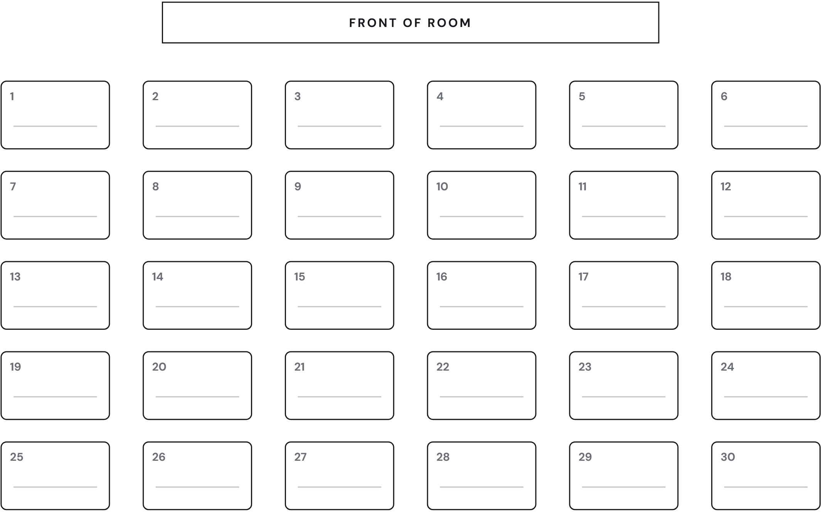

Student | What to Know | What Helps
Classroom Organization
Contacts and Emergencies

Who to Ask | Name |  |  | Room or Ext.
Front Office
Principal
Nurse
Counselor
Teacher Next Door
Grade or Department Lead
Custodian
Tech Help
Emergency Folder and Class List |  |  | Where We Meet Outside
Fire Drill |  | Lockdown
Severe Weather |  | Medical Needs and Allergies
Classroom Organization
Notes for the Teacher
Please fill this in during the day and leave it on my desk. Thank you.

Substitute |  | Date |  | Phone or Email
Class or Time | What We Did |  |  |  | How It Went
Absent Students |  |  | Students Who Were a Great Help
Students Who Had a Hard Time |  |  | Messages, Visitors and Anything Else

