Classroom Organization
Calm Down Strategies
Cut the cards apart, punch a hole in each corner and keep them on a ring in the calm down corner.

Take Five Breaths  Trace your hand, breathing in up and out down. | Balloon Breath  Fill your belly like a balloon, then breathe out.
Count to Ten  Count slowly from 1 to 10 in your head. | Square Breathing  In for 4, hold for 4, out for 4, hold for 4.
Squeeze and Let Go  Make tight fists for 5 seconds, then let go. | Five Senses  See 5, touch 4, hear 3, smell 2, taste 1.
Get a Drink  Take slow sips of cold water. | Stretch  Reach up high, then slowly touch your toes.
Draw How I Feel  What color is your feeling? How big is it? | Ask for Help  Tell a teacher or a friend how you feel.
Classroom Organization
How Do I Feel?
Point to the face that shows how you feel, then to how big the feeling is and what can help.

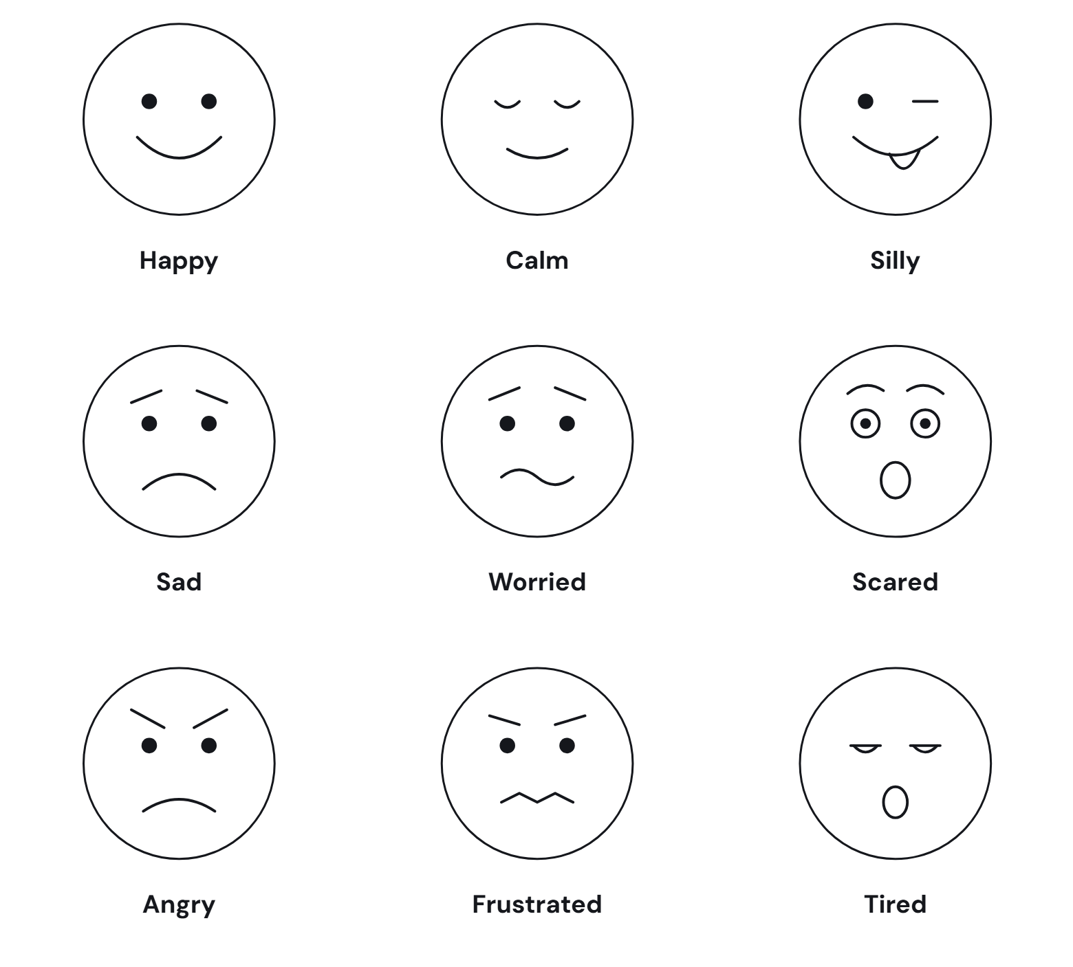

How Big Is My Feeling?
1 | 2 | 3 | 4 | 5
Tiny | Small | Medium | Big | Huge
Keep Going | Take a Breath | Use a Strategy | Take a Break | Ask for Help
Classroom Organization
Calm Down Check-In
Fill this in when you feel calm and ready.

Name |  | Date
Before, I Felt | I Tried |  | Now I Feel
☐ Angry  ☐ Sad  ☐ Worried  ☐ Scared  ☐ Frustrated  ☐ Tired | ☐ Breathing  ☐ Counting  ☐ Squeeze and Let Go  ☐ Five Senses  ☐ Drawing  ☐ Talking to Someone |  | ☐ Calm  ☐ Better  ☐ A Little Better  ☐ Still Upset
What Happened? Draw or Write
Next Time I Can
I Am Ready To

