Classroom Organization
Band Seating Chart

Ensemble | Director | Concert or Event | Date

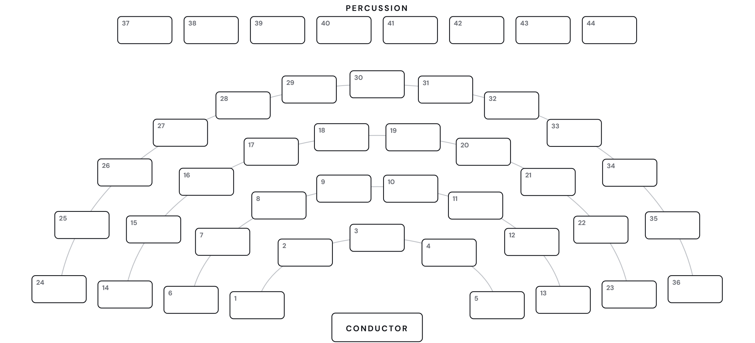

Sections and Chairs | Notes

