Behavior Charts
Token Board
Choose the reward together. Give a token right after the behavior and say what the student did. Five tokens earn the reward.

Name | Date
I Am Working For

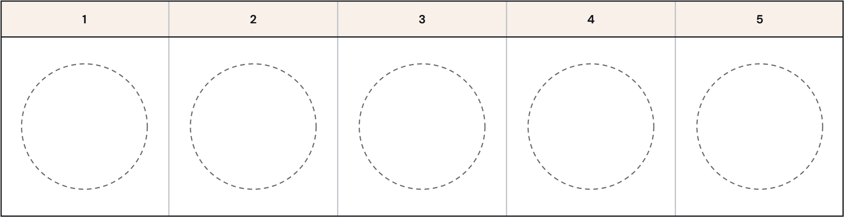

I Earn a Token When I

