Behavior Charts
Smiley Face Behavior Chart
Each day, color in a smiling face for every goal you met. Count your smiles on Friday.

Name |  | Week of
Goal 1 | Goal 2 |  | Goal 3

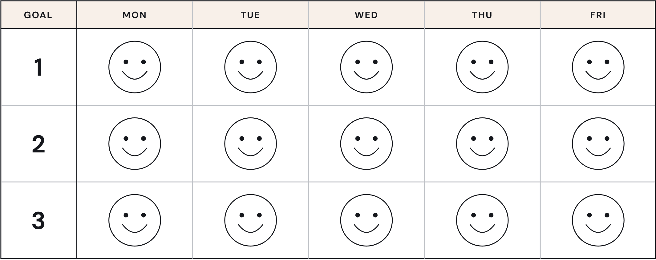

Smiles This Week | Smiles I Need
I Am Working For | Note Home
Teacher | Family Signature

